Year 11 G.C.S.E Dance Revision Guide

Go through each section in the booklet and highlight using the following traffic light system:

Confident areas in Green
Revision areas in Orange
Weak areas in Red
Good Luck!

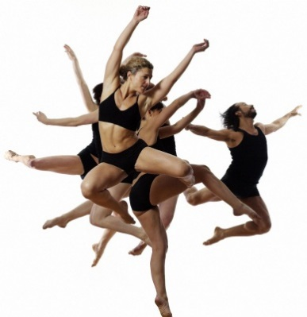
Performance

Technical and Expressive Skills
Key Questions:
- Why do we need good technique?
- What is a technical skill?
- What is an expressive skill?
Learn the following definitions- Please see technical skills document on the website, the definitions are much more detailed
Technical Skills | Definition
Posture, placement and alignment | How you stand, how bones are stacked, how you hold positions.
Co-ordination | Moving the arms, legs and head simultaneously
Control | Managing to hold body shapes in air, floor, travelling, how you land after a jump
Mobility | Flexibility in motion.
Strength | Using muscles to hold body shapes, take on your own or others weight
Balance | A steady or ‘held’ position on one or multiple points of the body
Flexibility | The range of movement that is attainable at a joint.
Expressive Skills | Definition
Focus | Where you are looking (at your hand, out to the audience etc.), using the eyes to enhance performance or interpretive qualities.
Projection | When a dancer gives out appropriate energy to connect with an audience and draw them into the performance.
Musicality | The ability to pick out the unique qualities of the accompaniment and make them evident through the performance (using all your counts)
Sense of style | When a dancer is able to emulate the distinctive actions and qualities of the dance e.g sharp dynamics for street dance.

Achieving high quality performance

Key questions:
- How can you improve the quality of your own performance work?
- What factors are important for effective rehearsal?
- How do you communicate effectively with the audience?

Rehearsal Technique | Definition
Partner Work | Buddying up with a partner and giving constructive feedback.
Whole Class Feedback | Watching your class and providing collective whole-class feedback.
Mental Rehearsal | Visualising your performance in your head without moving
Personal Feedback | Using mirrors to correct technique or enhance expressive qualities.
Personal Targets | Setting targets to work towards.
Teacher Feedback | A teacher watching and giving verbal or written feedback
Audience Feedback | Rehearsing in front of an audience and getting feedback from a few audience members. Then: Perform – Refine – Evaluate – Perform again.
Video Feedback | Asking someone to record your performance on video so that you can evaluate your own work
Rehearsal Plan | Design a rehearsal plan of the aspects you intend to work on for each session.

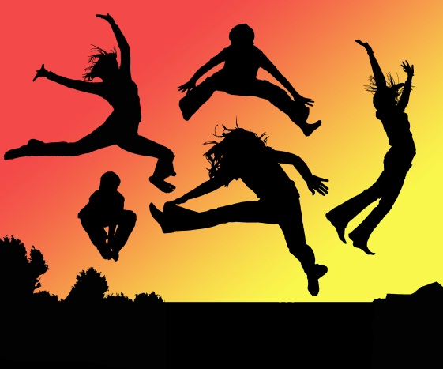
Key Questions:
- How can you use actions to portray different dance themes e.g. anger?
- Why is it important to have a range of different actions in a dance?

Gesture
This is a non-weight-bearing movement of the limbs mostly associated with the arms but also can apply to the legs, the head and the torso.

Travel
The act of moving from one point in space to another. This could be a simple action of walking or running, or something more structured and complex.

Flight
This refers to any movement that is not in contact with the floor. Flight can refer to huge jetés or even the smallest of hops.
Actions
Gesture
Travel
Stillness
Flight
Rotation

Stillness
This is quite simply a pause within movement; a complete stop, a balance or even a suspension between movements.
Rotation

This occurs when the body or a body part is turned, twisted or coiled. This action also covers movements like rolling and pirouettes.
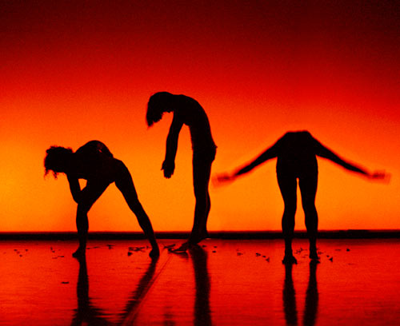
Space

What is Space?

Space is where the body is moving. This can involve:
- Where the dancer is placed onstage e.g.
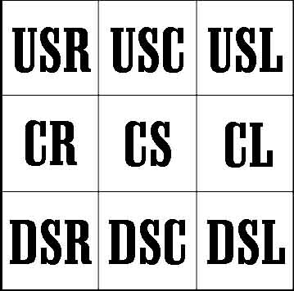
- The direction the dancer is facing e.g. right hand side, right hand corner, front, back.

- The pathways the dancer is using e.g.

- The level the dancer is on- high, medium, low.

- The size and shape of the movement

- Group formations e.g.

Key Questions:
How can you develop a motif using space?
If the subject of the dance is ‘water’ how could you use space to communicate the idea to the audience?

Dynamics
Key Questions
What are dynamics?
How could you use dynamics as part of a climax?
If you were choreographing a dance based on ‘fire’ what kind of dynamics would you use to help communicate the idea to the audience?
Dynamics are HOW the body is moving. This can be divided into 3 categories: speed, energy, flow. Below are some words to describe dynamics.

Strong
Free
Explosive
Smooth
Jagged
Heavy
Fast
Soft
Dynamics

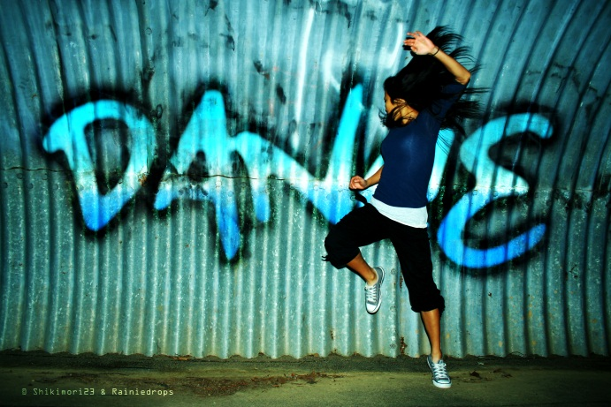
What is a stimulus?
Stimulus
Stimulus means starting point and it is something that inspires you to create a dance.

Why are stimuli important?
To help you to develop your creative and problem-solving skills and originality. Using different stimuli will help you find new ways of moving and appreciate the dances you watch.
Auditory- sound
Different types of stimuli
Visual
Poem or artwork
Kinaesthetic
Movement or steps

Ideational -idea or theme
Tactile e.g. some material

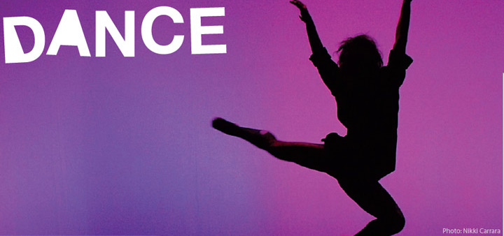
Motif And Motif Development
Key Questions

- What is a motif?
- Why are motifs important?
- How do you develop a motif?

A Motif is a basic phrase of 4 or more movements and can be repeated, varied and developed to help structure and organise a dance. They are important as they help communicate the intention of the dance and the choreographer’s style to the audience.

You will need to be able to describe a motif from each professional work and also one from your own choreography. Remember that you must mention the following when describing a dance:

ACTION SPACE DYNAMICS RELATIONSHIPS
ACTION  (what a dancer does)  Travel  Jump  Turn  Gesture  Stillness | SPACE  (where the action happens)  Personal / General  Level  Direction  Pathways  Shape  Size
DYNAMICS  (how a dancer does the action)  Fast / Slow  Sudden / Sustained  Heavy / Light  Flowing / Jerky  Sharp / Soft | RELATIONSHIPS  (who or what the dancer is dancing with)  Solo  Duet  Groups  Action and Reaction  Unison / Canon  Counterpoint/Fragmentation
To start to describe something, begin with the action:
The dancer lifts her right arm out to the side and straight over her head, in a semi-circle.
Then add the space:
She is facing the audience, in the centre of the stage, but focusing on her right hand.
Then dynamics:
The dancer moves her hand very slowly; it takes 8 counts to complete the movement.
Then relationships:
She is alone on stage.

Please refer to your choreography bible for motif development and relationships (compositional devices).
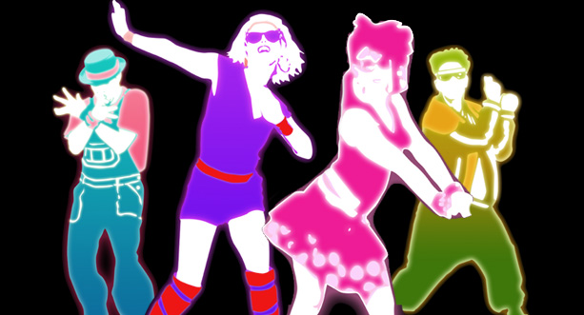
Choreographic Devices

A Choreographic device is a method applied to a movement phrase that changes or develops the phrase. There are many devices which help choreographer to create new and inventive ways in which the body can move and perform movements.
These can include anything from the following list:
- Motif Development
- Contrast
- Highlights
- Climax
- Dance Relationships

KEY QUESTIONS

How does the choreographer use choreographic devices in the works you have studied to convey the meaning of the dance to the audience?
You will need to know the definitions of all the choreographic devices as there may be a question asking you to define one of them. These can be found in your textbook.

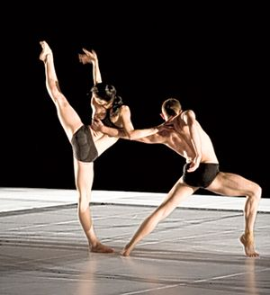
Climax and Highlights

What is a climax…?

“The most important or significant moment of the dance, which usually happens near the end”
“The portion of the composition given primary emphasis or representing culmination; the most intense or highest point in the development or resolution of choreography.

Key Questions
What is a climax? What is a highlight? How can a climax be created?
Give an example of a climax/highlight from a professional work.
Explain the importance of a climax in a dance piece.
Questions
(All the answers can be found somewhere in the revision guide!)

- Why do we need good technique?
_________________________________________________________________
_________________________________________________________________

- What is a technical skill?
_________________________________________________________________
_________________________________________________________________

- What is an expressive skill?
_________________________________________________________________
_________________________________________________________________

- How can you improve the quality of your own performance work?

_________________________________________________________________
_________________________________________________________________

- What factors are important for effective rehearsal?

_________________________________________________________________________
_________________________________________________________________________

- How do you communicate effectively with the audience?

_________________________________________________________________________
_________________________________________________________________________

- How can you use actions to portray different dance themes e.g. anger?
_________________________________________________________________
_________________________________________________________________

- Why is it important to have a range of different actions in a dance?
_________________________________________________________________________
_________________________________________________________________________

- How can you develop a motif using space?

_________________________________________________________________________
_________________________________________________________________________________

- If the subject of the dance is ‘water’ how could you use space to communicate the idea to the audience?
_________________________________________________________________
_________________________________________________________________

- What are dynamics?
_________________________________________________________________
_________________________________________________________________
- How could you use dynamics as part of a climax?
_________________________________________________________________
_________________________________________________________________

- If you were choreographing a dance based on ‘fire’ what kind of dynamics would you use to help communicate the idea to the audience?
_________________________________________________________________
_________________________________________________________________

- What is a stimulus?
_________________________________________________________________
_________________________________________________________________

- Please describe a motif (actions, space and dynamics) from the Nutcracker and also one from your own choreography
_________________________________________________________________
_________________________________________________________________
_________________________________________________________________
_________________________________________________________________

- How does the choreographer use choreographic devices in the works you have studied to convey the meaning of the dance to the audience?
_________________________________________________________________
_________________________________________________________________
_________________________________________________________________
_________________________________________________________________

- What is a climax?
_________________________________________________________________
_________________________________________________________________

- What is a highlight?
_________________________________________________________________
_________________________________________________________________

- How can a climax be created?
_________________________________________________________________
_________________________________________________________________

- Give an example of a climax/highlight from a professional work.
_________________________________________________________________
_________________________________________________________________

- Explain the importance of a climax in a dance piece.
_________________________________________________________________
_________________________________________________________________

