**GCSE DANCE UNIT 4A**

**SOLO COMPOSITION**

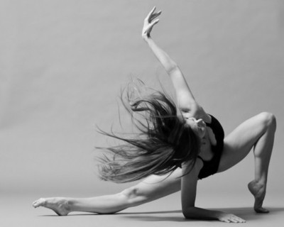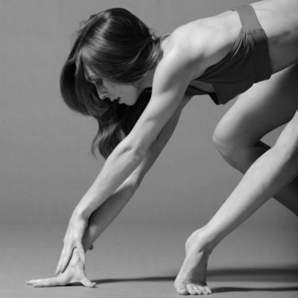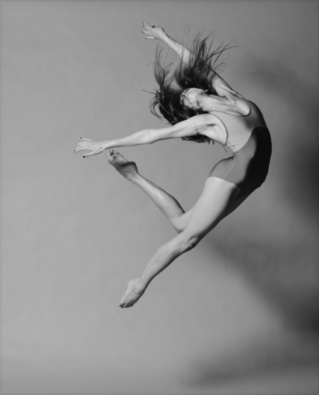

**Name:**

**Candidate No:**

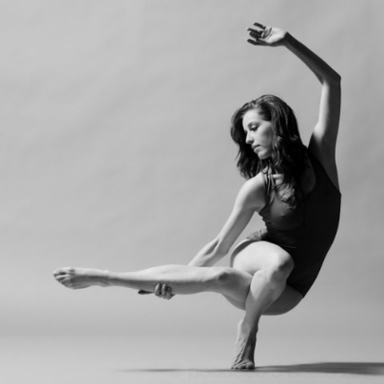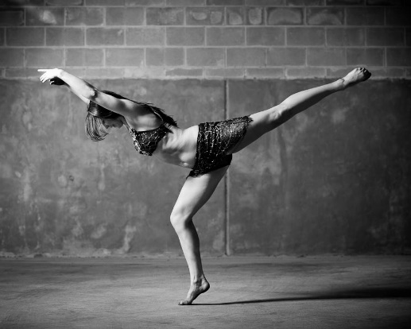***15% of the GCSE***

***20 marks***

**Requirements**………Your dance must be:

* A solo dance
* 1 - 1.5 minutes long
* Based on 3 motifs from a professional work
* You must fill in and hand in this booklet: worth 5 marks

**THE MOTIFS**

What is a motif? ________________________________________________________________

The professional work my 3 motifs are from is

________________________________________________________________

Choreographed by: ________________________________________________________________

In_____________ (date)

The dance is about:

________________________________________________________________________________________________________________________________

**MOTIF 1**

|  |  |
| --- | --- |
| Where in the dance is this motif? |  |
| Describe motif 1 (ACTION) | Please number these movements so on the development pages you can refer to numbers instead of writing out all the movements again |
| How are SPACE and DIRECTION used in motif 1? |  |
| What are the DYNAMICS of motif 1? |  |
| Draw the key moments/positions in motif 1 |  |

**MOTIF 2**

|  |  |
| --- | --- |
| Where in the dance is this motif? |  |
| Describe motif 1 (ACTION) |  |
| How are SPACE and DIRECTION used in motif 1? |  |
| What are the DYNAMICS of motif 1? |  |
| Draw the key moments/positions in motif 1 |  |

**MOTIF 3**

|  |  |
| --- | --- |
| Where in the dance is this motif? |  |
| Describe motif 1 (ACTION) |  |
| How are SPACE and DIRECTION used in motif 1? |  |
| What are the DYNAMICS of motif 1? |  |
| Draw the key moments/positions in motif 1 |  |

**MOTIF DEVELOPMENT How can I develop a motif?**

**ACTION**

* Addition/Reduction
* Change of body parts
* Change the order of the action
* Repetition
* Retrograde

**See Choreography Bible For More Ideas!!!**

**SPACE**

* Face a different direction
* Perform it in a different space
* Change the levels (high, medium, low) or plane (standing, lying down)

**See Choreography Bible For More Ideas!!!**

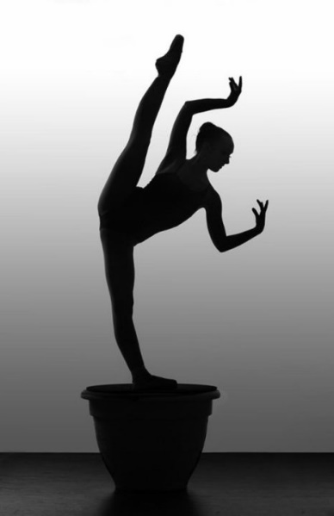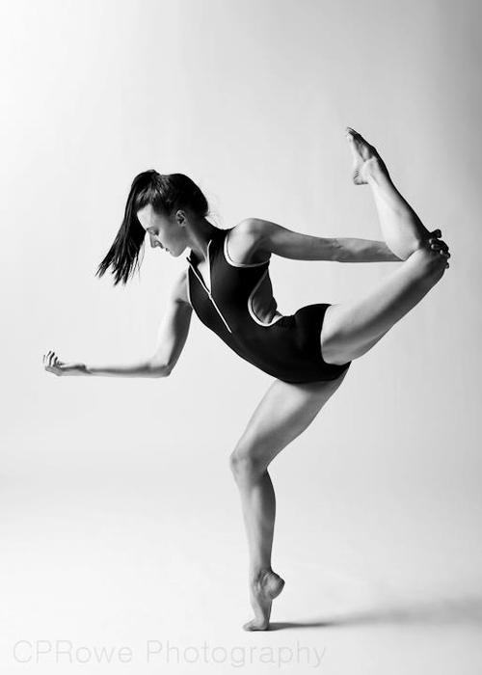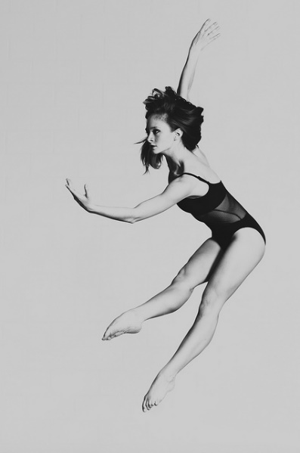

**DYNAMICS**

* Perform with more or less force (eg. gentle, soft, spiky, sharp)
* Change tempo (speed)

**CHOREOGRAPHIC DEVICES (CDs)**

* Fragmentation: break into little parts
* Accumulation 1, 12, 123, 1234 etc
* Contrasting and complementary movements (similar and different)
* Highlights: Important moments
* Climax: the main high point of the dance

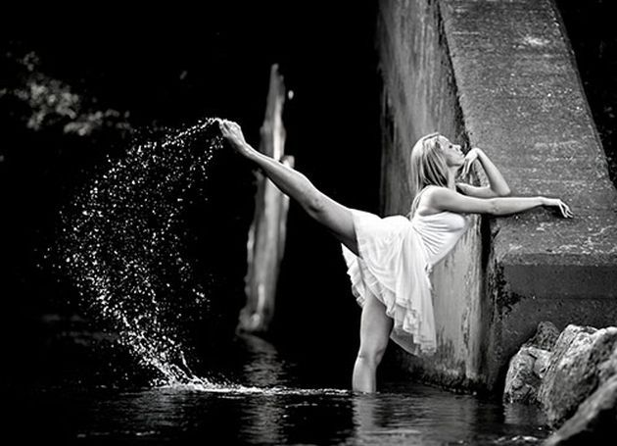

**ACCOMPANIMENT**

* You must choose accompaniment for your solo composition.
* Accompaniment should be between 1 and 1.5 minutes.
* Popular / chart music may not be used.
* Music must be edited.
* It is helpful if there is a change of tempo or dynamic within the music.

Your teacher must agree your choice of music.

You will have help with this.

What accompaniment have I chosen?

________________________________________________________________________________________________________________________________

Why have I chosen this?

________________________________________________________________________________________________________________________________________________________________________________________________________________________________________________________________

**MOTIF 1 DEVELOPMENTS**

|  |
| --- |
| You should use the following example layout for writing down your motif developments (use different colour pen for the developments):   1. Start crouched down, jump up to right hand side left leg out (original) I have developed this by changing the order to move 7 and changing the direction to face the back. |

**MOTIF 2 DEVELOPMENTS**

|  |
| --- |
| You should use the following example layout for writing down your motif developments (use different colour pen for the developments):   1. Start crouched down, jump up to right hand side left leg out (original) I have developed this by changing the order to move 7 and changing the direction to face the back. |

**MOTIF 3 DEVELOPMENTS**

|  |
| --- |
| You should use the following example layout for writing down your motif developments (use different colour pen for the developments):   1. Start crouched down, jump up to right hand side left leg out (original) I have developed this by changing the order to move 7 and changing the direction to face the back. |