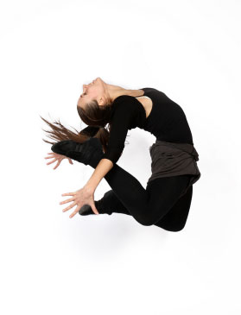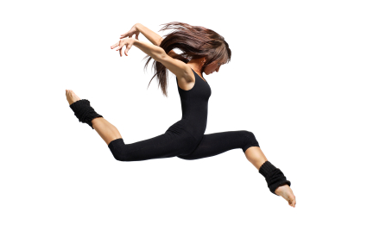

All dances need to begin somewhere, build toward something, and come to a resolution (beginning, middle, and end). When a dance builds in intensity and interest and reaches a high point, the high point is called a climax. A climax can be created in many ways. For example, dance phrases can increase in intensity of energy and speed to a high point before decreasing to a lull, or a narrative can build toward a highlight or a turning-point before being resolved.
The resolution of a climax reveals the importance of what has occurred previously in the composition. Climaxes can be resolved in a variety of ways; for example, the climax could dissolve, be converted into something else, or be replaced by something else.

Where should the climax in your dance be?
...................................................................................................................................................
...................................................................................................................................................

What is the build up to your climax?
...................................................................................................................................................
...................................................................................................................................................

How do the dynamics change to show your climax?
...................................................................................................................................................
...................................................................................................................................................

What happens after your climax?
...................................................................................................................................................
...................................................................................................................................................

