Choreographer’s Guide


^{The} FIVE BODY ACTIONS
What are they?  The five body actions are a way of categorising movement. By being able to identify and create movement from each of the five will ensure that movement vocabulary is rich and varied. The five are: Rotation, Stillness, Gesture, Flight and Travel. |  |  | 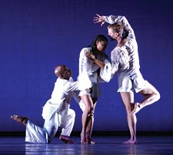.
Rotation  This occurs when the body or a body part is turned, twisted or coiled. This action also covers movements like rolling and pirouettes. |  |  | Stillness  This is quite simply a pause within movement; a complete stop, a balance or even a suspension between movements.
Gesture  This is a non-weight-bearing movement of the limbs mostly associated with the arms but also can apply to the legs, the head and the torso. |  |  | Flight  This refers to any movement that is not in contact with the floor. Flight can refer to huge jetés or even the smallest of hops.
Travel  The act of moving from one point in space to another. This could be a simple action of walking or running, or something more structured and complex. |  |  | A question of difficulty
 |  |  | In their single form, the five body actions can be simple, creating movement that is clear and visually striking. To make movement more complex, visually interesting and original, the body actions should be combined as much as possible; performing body actions simultaneously.
MOTIFS
What are they?  Motifs are a number of dance movements that can be repeated, expanded and developed within a dance. Motifs help to create form and structure within a dance and can often help communicate theme, narrative or notion. |  |  |  |  | 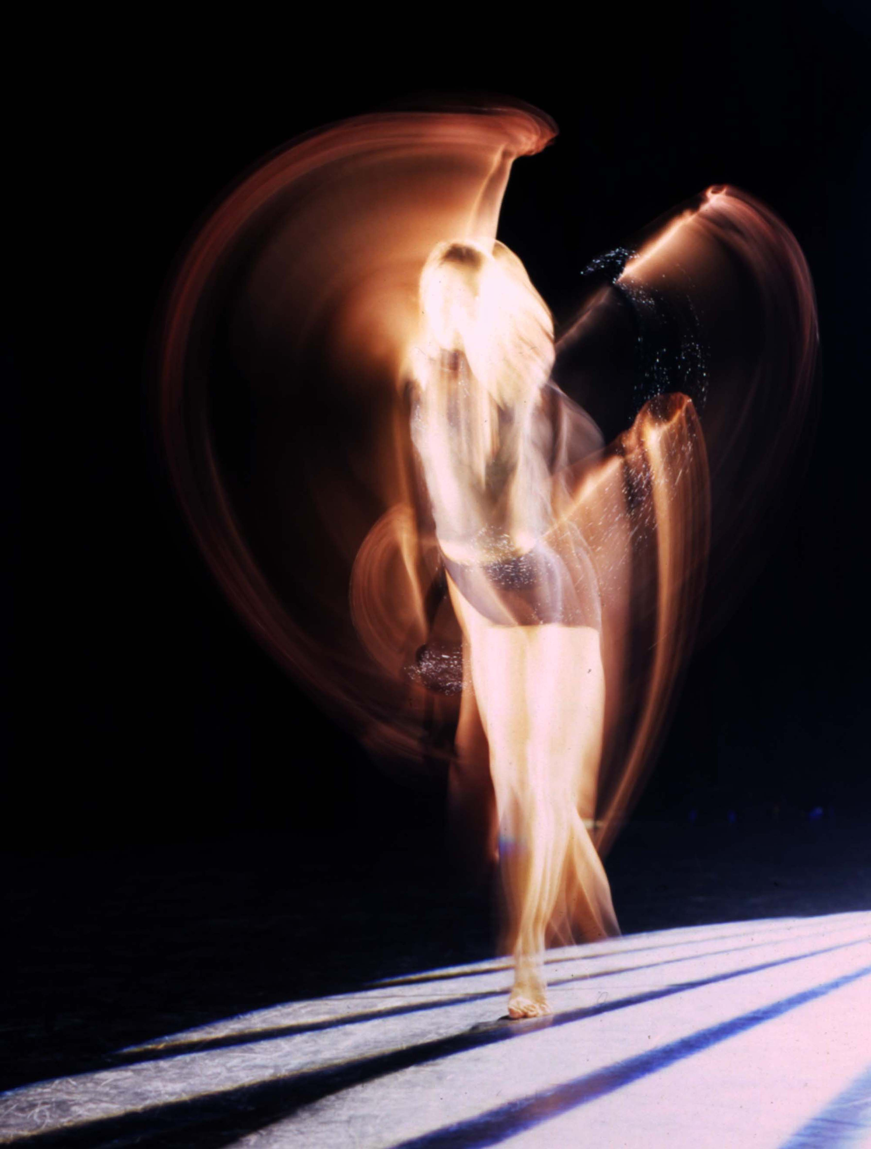
Why should motifs be used?  Motifs should be used in order to communicate the choreographer’s intentions. These motifs can then be developed as the intention develops, helping the audience to understand. An audience that does not understand does not like! |  |  |  |  | “An audience that does not understand does not like!”
 |  | What makes a good motif?
The Five Body Actions  Simply, a motif that contains a combination of the five body actions will always be more varied and have greater scope for original development. |  |  |  |  | Originality  This can make your good motif a great motif. Find new and innovative ways of moving: can you dance without using your left leg?
“Find new and innovative ways of moving: can you dance without using your left leg?” |  |  |  |  | Dynamics, space and time  Music that is the same pace and beat is repetitive and boring. Do you want your dance to be? Use a variety of dynamics, space and timing.

MOTIF DEVELOPMENT
What is it?
Motif development is the act of varying and changing the movements or the order of movements that comprise a motif. This can be done using three distinct categories of motif development: action, dynamics and space.
Why use it?
The development of motifs is essential in choreography, without it ideas cannot develop or climax and the piece will lack a sense of whole.
“…without it ideas cannot develop or climax and the piece will lack a sense of whole.”
In a perfect world…
The development of a motif would be partially dictated by the theme or stimulus of the original dance idea. This form of relevant motif development is known as the communication of the dance idea.
Communication of the dance idea.
The communication of the dance idea helps form part of the marking criteria for choreographic working in GCSE Dance; it is just as important as making sure you have motifs or that your dance is well rehearsed.

MOTIF DEVELOPMENT
Action Developments: |  |  | Addition
What is it?  This is the act of adding in new movement into an already existing motif. Movement could be added at any point in the motif: the beginning, middle or the end. By doing this you can create longer and more complex motifs. |  |  | 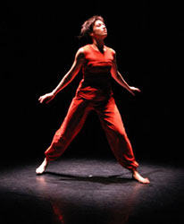
What could it mean?
This could mean a range of things, but most obviously this development could help to portray the idea of something or a situation becoming more complex.
What about...?
Try adding movements that are a complete contrast to your motif. It can help to highlight the qualities of the original movement by juxtaposing it directly. |  |  | Difficulty:
 |  |  | EASY

MOTIF DEVELOPMENT
Action Developments: |  |  | Reduction
What is it?  This is when movement is removed from the motif entirely, effectively shortening it. The easiest way of doing this is to remove movement from the beginning or the end. Extracting movement from the middle of a complex motif and making it seamless can be challenging. |  |  | 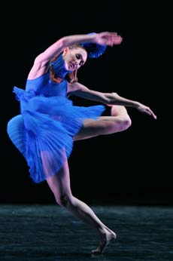
What could it mean?
This could be interpreted to mean things such as a sense of loss or a feeling of confusion. By extracting movement the motif is shortened and takes less time to perform, so it could help portray compaction.
What about...?
Try extracting movement from the middle of the motif and ‘sewing’ the hole up. This can create interesting and original transitions. |  |  | Difficulty:
 |  |  | EASY

MOTIF DEVELOPMENT
Action Developments: |  |  | Ornamentation
What is it?  Adding in extra ‘frilly bits’ to the motif. This could be done by adding flourishes within the body to add extra visual interest to a movement. For example, you could add a head spin to the movement, or a loop of the hips. This is not addition or amplification. |  |  | 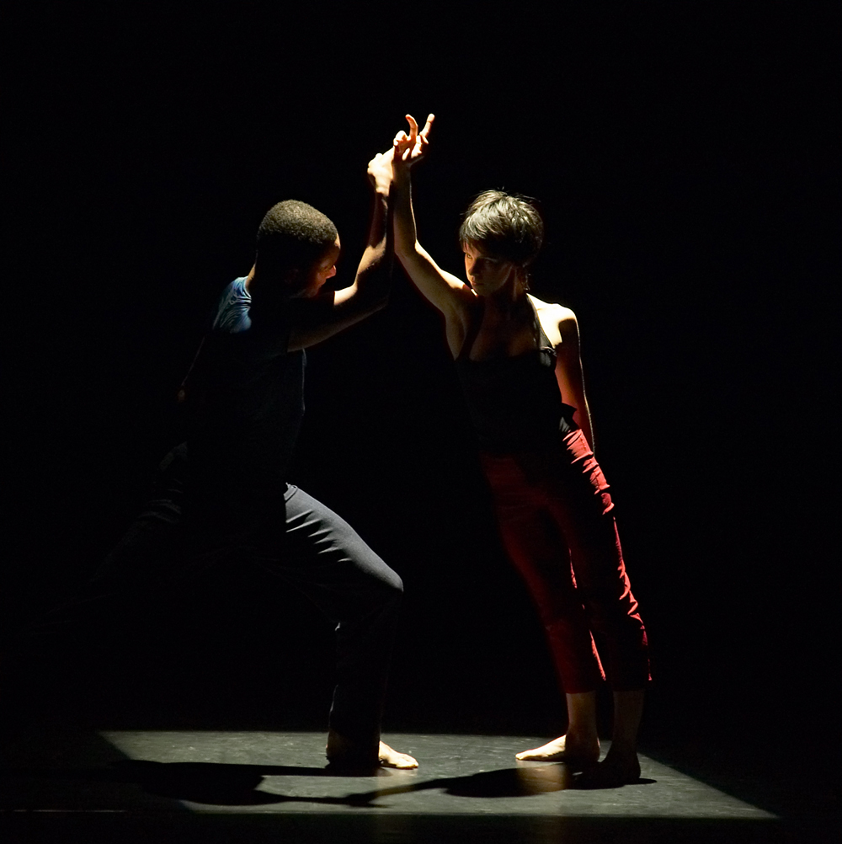
What could it mean?
This could be portrayed to mean an assertion of confidence or perhaps a sense of wealth (either literal or aesthetic). This could also have a narrative of someone rambling through a conversation.
What about...?
Ornamentation isn’t just about adding loops and wiggles; try ornamenting with flicks, rotations or flexion. Perhaps try a combination. |  |  | Difficulty:
 |  |  | MEDIUM

MOTIF DEVELOPMENT
Action Developments: |  |  | Body Part
What is it?  Use a different part of your body to carry out the same/similar move. Use a different part of your body to take your weight. |  |  | 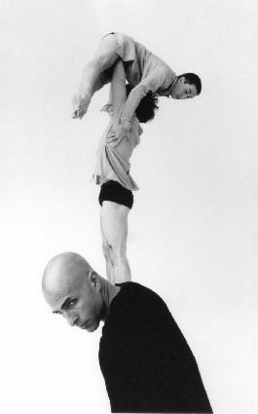
What could it mean?
This could be used to give a sense of confusion within a narrative context. Abstractly this development can be used to create interesting complementary movement.
What about...?
Try not to simply switch action from limb to limb (arm to leg). Experiment transferring movement to more obscure parts of the body. |  |  | Difficulty:
 |  |  | MEDIUM

MOTIF DEVELOPMENT
Action Developments: |  |  | Splicing
What is it?  Take two or more motifs and combine them with each other. Whole motifs or part motifs can be used in splicing. |  |  | 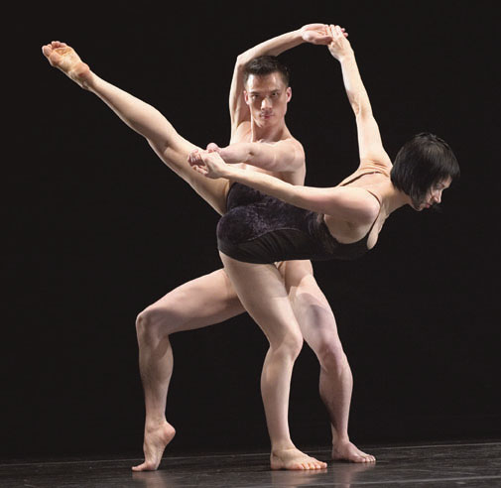
What could it mean?
This is open to interpretation but is generally used in abstract work for visual interest.
What about...?
How about mixing the motifs completely by stirring up movements from different motifs together rather than treating the parts separately. |  |  | Difficulty:
 |  |  | MEDIUM

MOTIF DEVELOPMENT
Action Developments: |  |  | Repetition
 |  |  | There are a range of repetitious forms that can be used to alter a motif:
Repetition |  | Repeating the entire motif in its original order.
 |  |  |  | EASY
Restate |  | Repeat exactly the same movement but on the other side of the body.
 |  |  |  | EASY
Reiterate |  | Perform the movement/motif over and over again until it dies away.
 |  |  |  | EASY
Accumulation |  | To accumulate pieces of the motif in order to gradually lengthen it.
 |  |  |  | MEDIUM
Reorder |  | To jumble the order of the movements within the motif to create a new order.
 |  |  |  | MEDIUM
Reverse |  | To reverse the order of the movements within the motif.
 |  |  |  | MEDIUM
Retrograde |  | To perform the movement completely backwards, as if being rewound on video.
 |  |  |  | HARD

MOTIF DEVELOPMENT
Space Developments: |  |  | Direction
What is it?  This is done by simply changing the direction the movement is facing. When using this it is easy to use poor movement alignment; always ensure that by changing the direction that the movement is not ‘blocked off’ from the audience. |  |  | 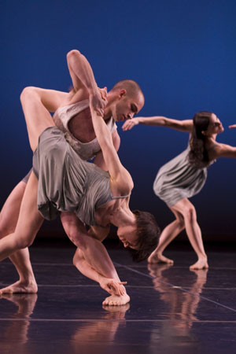
What could it mean?
In a narrative context this could be seen as shutting out or accepting somebody (depending on the facing). Abstractly it can give a new perspective.
What about...?
Try changing the direction many times within a motif, or perhaps even changing direction more than once within the same movement. |  |  | Difficulty:
 |  |  | EASY

MOTIF DEVELOPMENT
Space Developments: |  |  | Amplification
What is it?  To amplify something is to make something larger. This could be an enlargement of personal space or general space. |  |  | 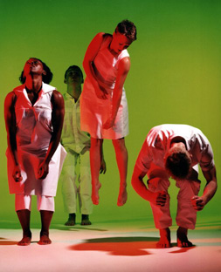
What could it mean?
Amplification is generally accompanied by a natural increase in power or energy. This can give the idea of the consumption or overwhelming of something or someone; it can also denote power.
What about...?
Normal amplification would involve the whole body. Try amplifying just a part of it and keeping the remainder the same. |  |  | Difficulty:
 |  |  | EASY

MOTIF DEVELOPMENT
Space Developments: |  |  | Miniaturisation
What is it?  This is the opposite of amplification. With this movement is reduced in size. This can refer to either personal or general space. |  |  | 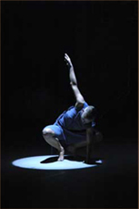
What could it mean?
Miniaturisation generally creates movement that is unusual and sometimes ugly. It can portray the idea of humility, fright or perhaps even pain.
What about...?
Normal miniaturisation would involve the whole body. Try miniaturising just a part of it and keeping the remainder the same. |  |  | Difficulty:
 |  |  | EASY

MOTIF DEVELOPMENT
Space Developments: |  |  |  |  |  | Level
What is it?  By changing the level of a movement the vertical space is changed. There are three identified levels of vertical space: low, medium and high. |  |  |  |  |  | 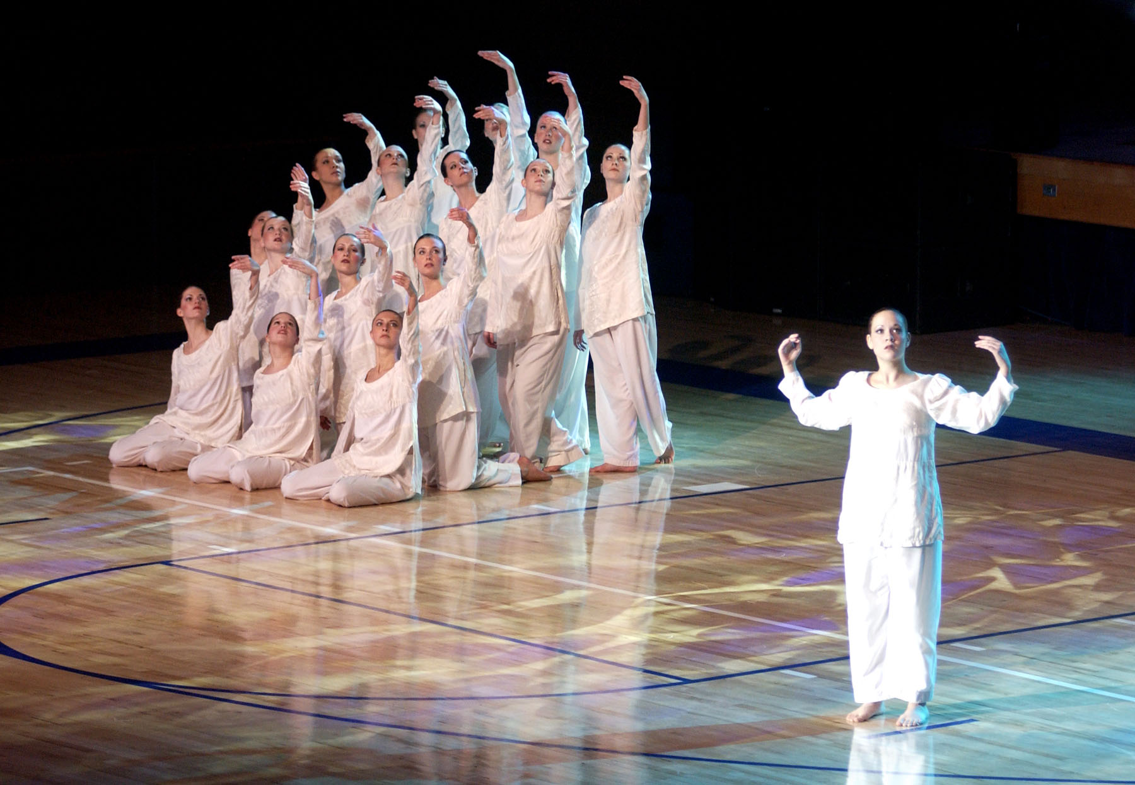  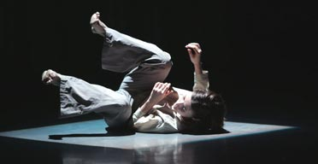
What could it mean?
The main narrative context for a level change would be to create a difference or a change of status. High levels generally convey a higher status.
What about...?
Do not just think about the three levels, think about a greater range. High could be on the toes or even up in the air. Try using the extremes of vertical space. |  |  |  |  |  | Difficulty:
 |  |  |  |  |  | MEDIUM
MOTIF DEVELOPMENT
Space Developments: |  |  |  |  | Plane
 |  |  |  |  | (No, not the flying variety!)
What is it?  Planes refer to the spatial pathway of movement; the corridors through which movement can happen.  Table: horizontal  Door: vertical side to side  Wheel: vertical front to back |  |  |  |  | 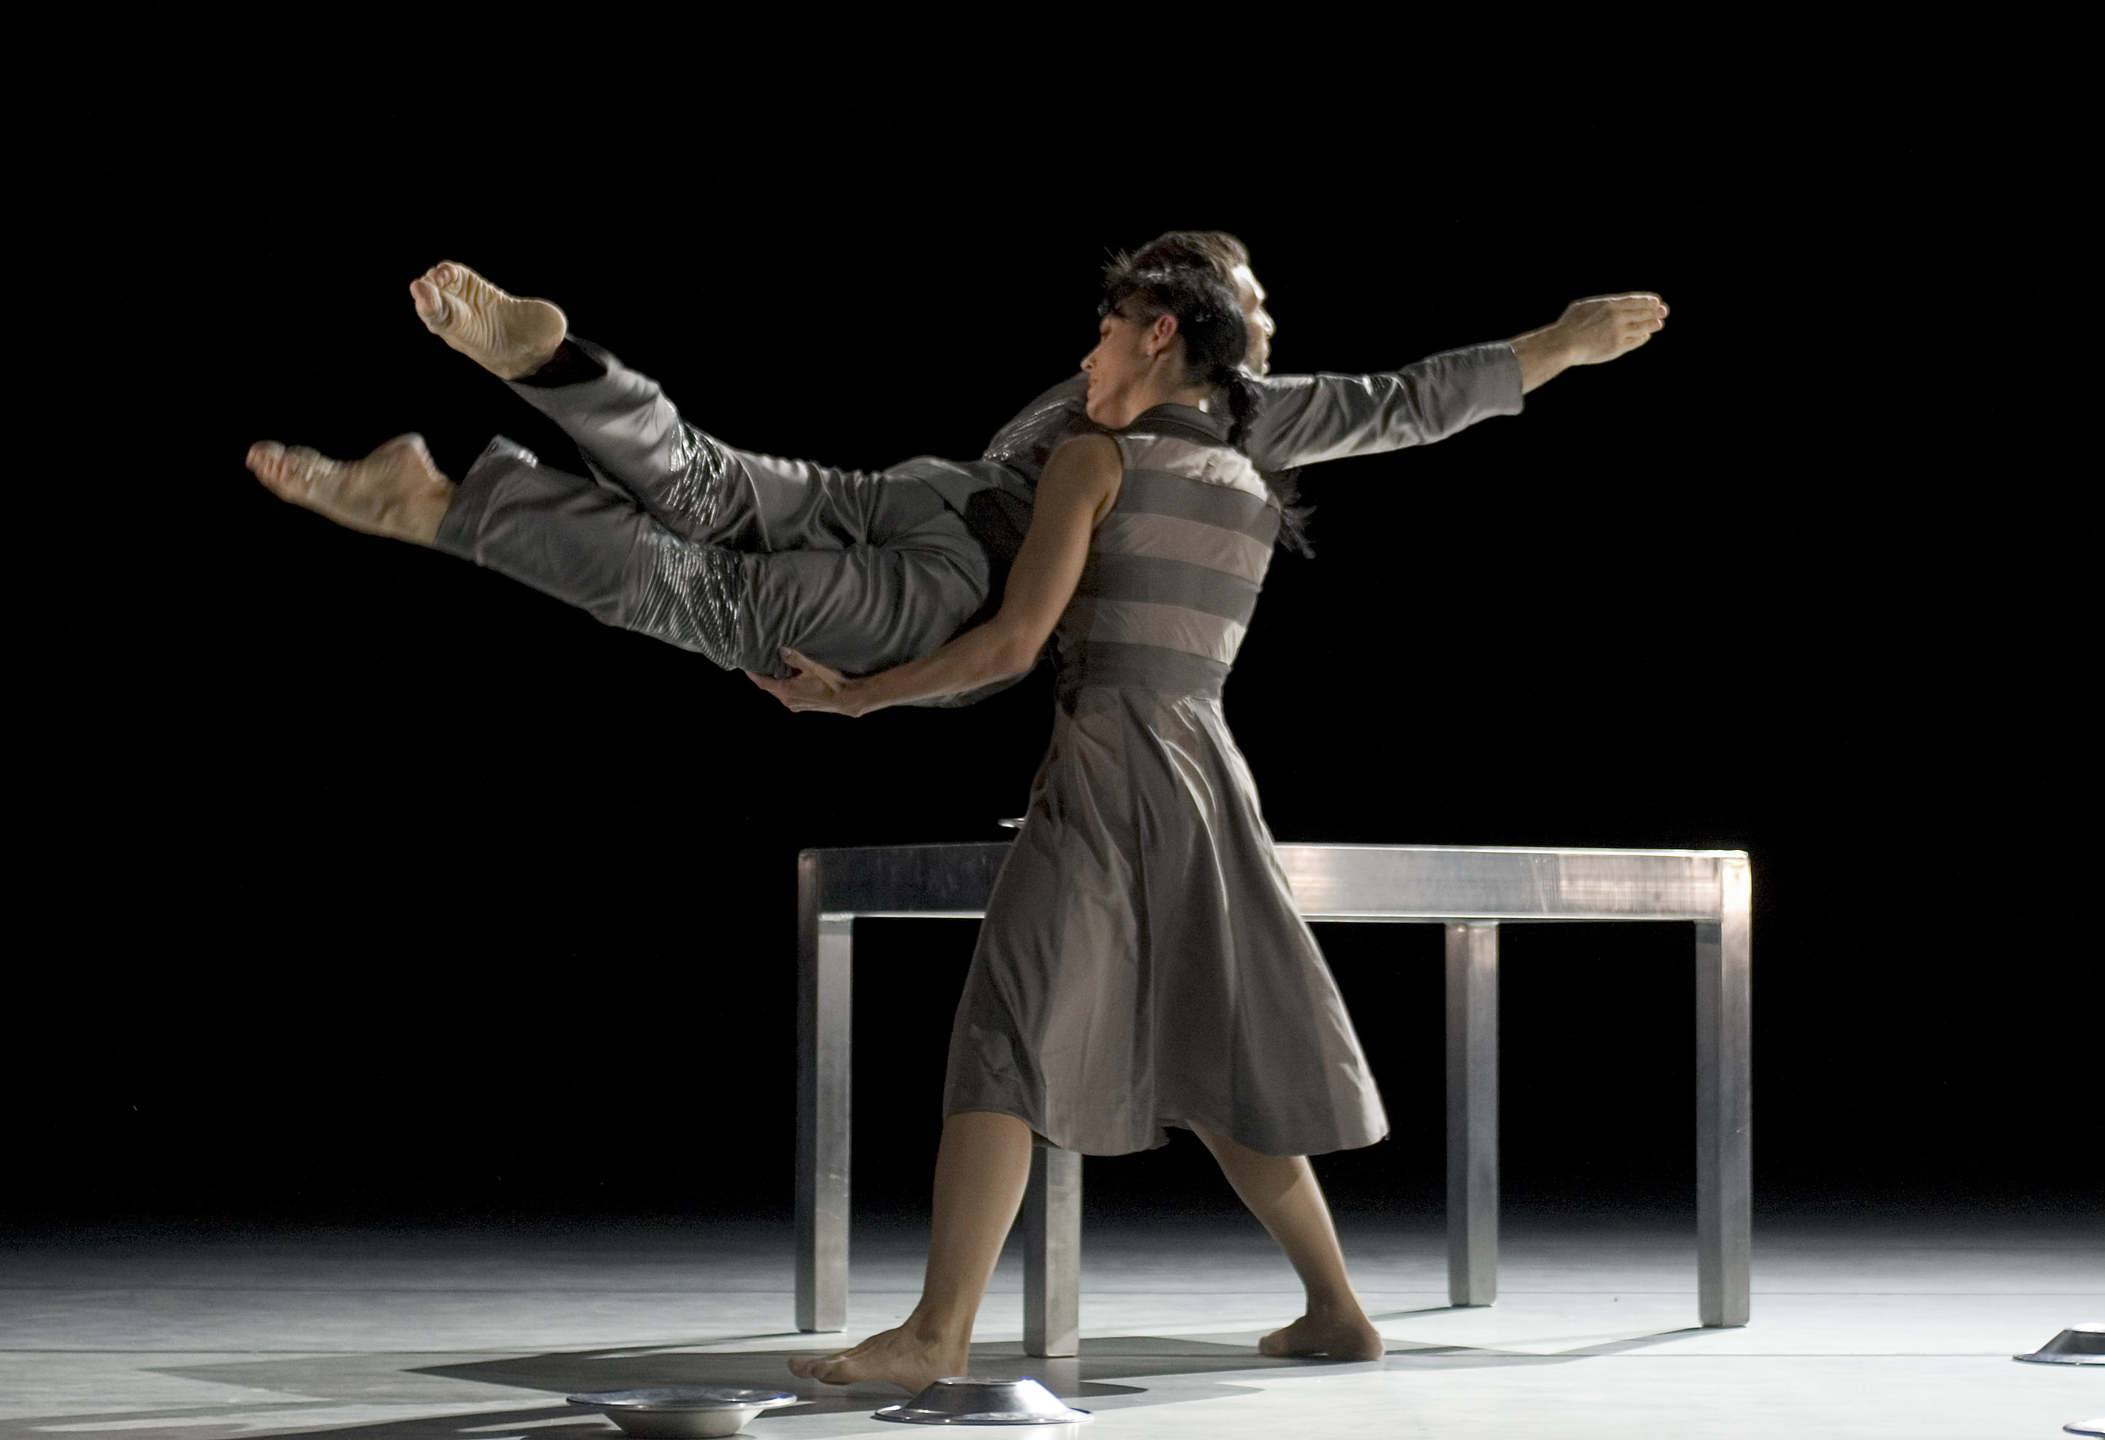  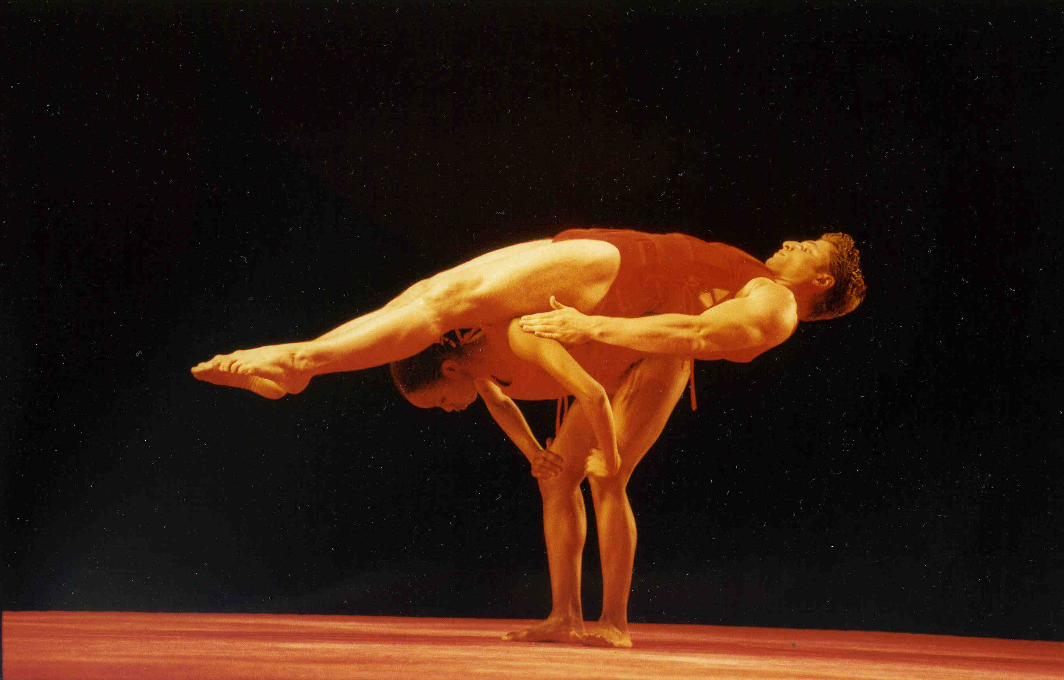
What could it mean?
This development is generally used in more abstract pieces for aesthetic reasons rather than for deep narrative contexts. This development can completely change the architecture of the dance space.
What about...?
This development is more difficult to explain than to actually do; try it! |  |  |  |  | Difficulty:
 |  |  |  |  | MEDIUM

MOTIF DEVELOPMENT
Space Developments: |  |  | Pathway
What is it?  A form of development that is usually overlooked, this refers to changing the path of a phrase of movement. Pathways can be linear, circular, angular, meandering, spiral, shaped, geometric, elliptical… |  |  | 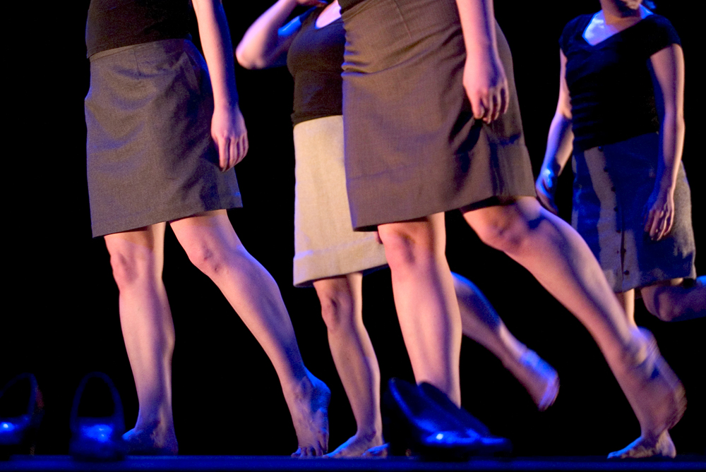
What could it mean?
This depends on the developed pathway that is used. If original is a linear pathway and the new one a meandering one it could convey a feeling of being lost.
What about...?
Pathways are not just the patterns made along the floor but also those created in the vertical space. Think about it. |  |  | Difficulty:
 |  |  | MEDIUM

MOTIF DEVELOPMENT
Space Developments: |  |  | Inversion
What is it?  This refers to the inversion of movement using the vertical axis. Movements are flipped 180 degrees, as if they have been turned on their head. Most of the time positions also need to be altered slightly in order to make it possible to invert them. |  |  | 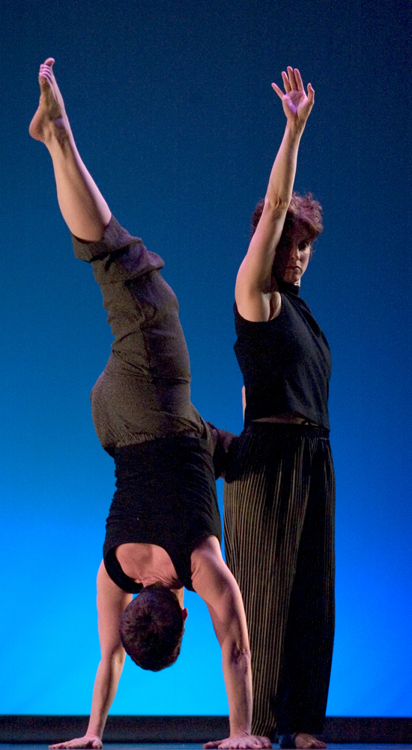
What could it mean?
As this development is heavily abstract and rarely seen in its pure form it can be open to a number of interpretations.
What about...?
One of the easiest ways of inverting a movement correctly would be to take the floor connection away; get lifting! |  |  | Difficulty:
 |  |  | HARD

MOTIF DEVELOPMENT
Dynamic Developments: |  |  | Speed
(this refers to developments of energy, space and time) |  |  | “…the fastest moving thing on stage often attracts the most attention.”
What is it?  Fairly self-explanatory development of adjusting how much time movements take to perform; to be sped up or slowed down. |  |  | 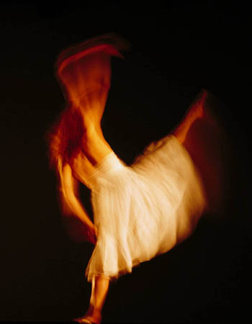
What could it mean?
This can be used for numerous reasons. The most important thing that needs to be remembered is that the fastest moving thing on stage often attracts the most attention.
What about...?
Don’t be afraid of using extreme speeds, particularly movement that is incredibly slow – it can be highly visually effective when used well. |  |  | Difficulty:
 |  |  | EASY

 | MOTIF DEVELOPMENT
 | Dynamic Developments: |  |  |  | Dynamics
 | What is it?  This is to change the QUALITY and ENERGY of the performance of movement. There are innumerable amounts of different dynamics that can be applied to movement. For example: sharp, loose, languid, staccato, whiplash, juicy, weighted. |  |  |  | 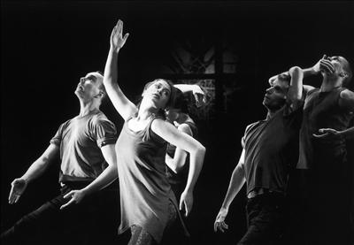  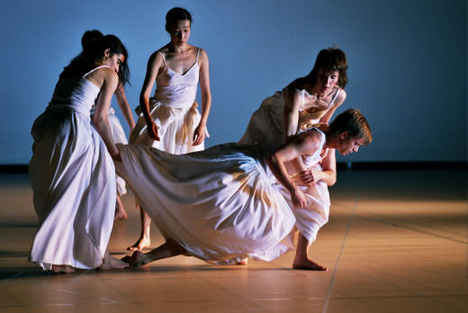
What could it mean?
This is the most powerful form of development as it changes the performance quality; therefore different dynamics have different uses and interpretations. Experiment!
 | What about...?
 | Try creating your own dynamics; the more descriptive the word the easier the dynamic should be. Try onomatopoeic words! |  |  |  | Difficulty:
 |  |  |  |  | MEDIUM
MOTIF DEVELOPMENT
Dynamic Developments: |  |  |  |  |  | Rhythm
What is it?  To change the rhythm is NOT to change the speed of movement but to change the punctuation and accent of it. Rhythm is the structuring of action and stillness. Change the pauses between movements. |  |  |  |  |  | 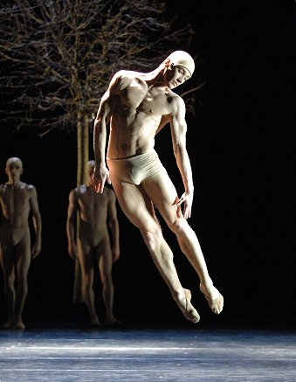
What could it mean?
Depending on the rhythm and whether or not it is made audible (can be heard) it can be made to express obvious emotion. A bright and punchy rhythmic foot pattern could be interpreted as a moment of joy.
What about...?
Rhythm is not just limited to the punctuation of foot patterns; try changing the rhythmic patterning of gestures or other types of movements. |  |  |  |  |  | Difficulty:
 |  |  |  |  |  | MEDIUM

COMPOSITIONAL DEVICES
And these are…?
Compositional devices are choreographic constructs that are applied to group relationships. These change and manipulate how dancers dance with one another within a group.
But why?
Like motif development, compositional devices are crucial to creating successful choreography. Often these give an audience the greatest incite into the relationships between dancers and when used properly can be visually striking.
In a perfect world…
Like with motif development, compositional devices may be partially dictated by theme or narrative. Often compositional devices can be a clearer way of communicating a relationship-based idea than motif development.
 |  |  |  |  | “These change and manipulate how dancers dance with one another within a group.”
 |  | 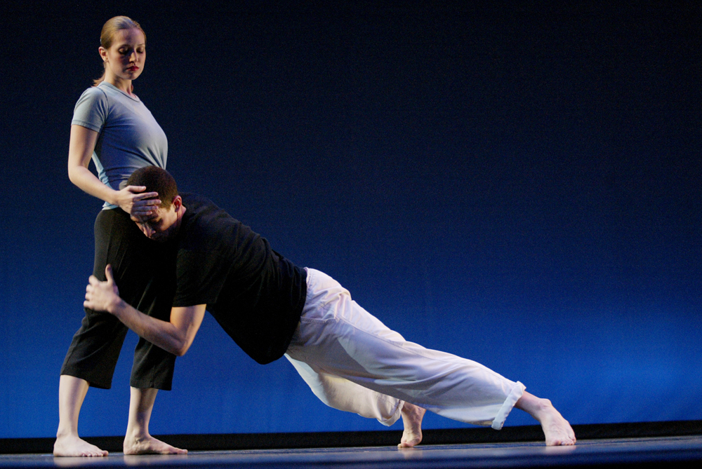
COMPOSITIONAL DEVICES
Unison
 | 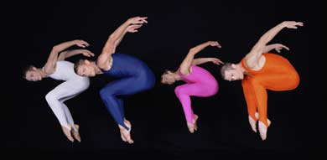
This is…?  A group of dancers performing the same movement at the exact same time as one another. |  |  |  |  |  | What does it all mean?  Unison could be used to give an element of unity or harmony. With strong dynamic movement it can also help give a sense of power and solidarity.
Mr R recommends…
…to use unison sparingly. When used in very small fleeting instances within large blocks of canon, it can be stunning, and quite clever. |  |  |  |  |  | Difficulty:
 |  |  |  |  |  | EASY

COMPOSITIONAL DEVICES
Canon: Simple
 | 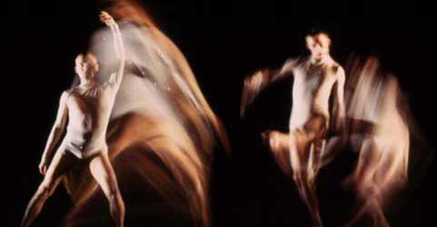
This is…?  Dancers dance the same phrase but one after another in consecutive sequence. Think of a Mexican Wave! |  |  |  |  | What does it all mean?  Contrary to popular belief canon does not automatically mean disparity within a group. In fact it can be used as a way of reiterating a significant movement.
Mr R recommends…
  Example…
  A |  | 1 | 2 | 3 | 4
  B |  |  | 1 | 2 | 3 | 4
  C |  |  |  | 1 | 2 | 3 | 4
  D |  |  |  |  | 1 | 2 | 3 | 4
…against using lots of this, it can become dull quickly and by its nature is very predictable. Use with care and thought. Also, try overlapping the canon.
COMPOSITIONAL DEVICES
Canon: Random
 |  | 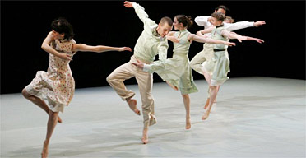
This is…?  Dancers dance the same phrase but one after another in a random order and at random times; it’s unpredictable. Think of Whack Attack! |  |  |  |  | What does it all mean?  Contrary to popular belief canon does not automatically mean disparity within a group. In fact it can be used as a way of reiterating a significant movement.
Mr R recommends…
  Example…
  A |  |  |  | 1 | 2 | 3 |  | 4
  B |  | 1 | 2 |  | 3 | 4
  C |  |  | 1 |  |  | 2 | 3 | 4
  D |  |  |  |  | 1 | 2 | 3 | 4
…trying this form of canon and using pronounced pauses at the same time to add extra weight to the unpredictability.

COMPOSITIONAL DEVICES
Canon: Cumulative |  |  | “Cumulative canon is good for building to a climax.”
 | 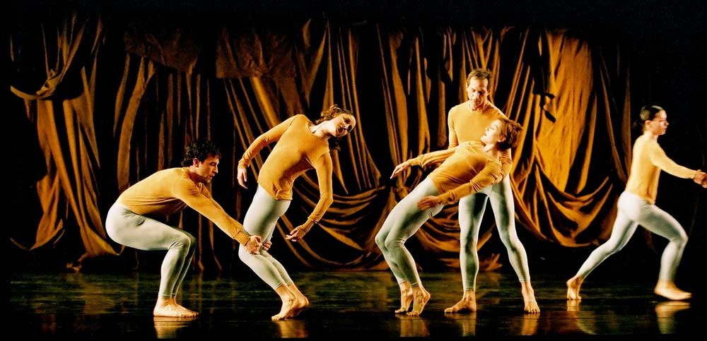
This is…?  One dancer will start a phrase and other dancers will join in at various stages, finishing at the same time as the original dancer. |  |  | What does it all mean?  This form of canon is very clear to see; a strong visual device. With dancers being ‘collected’ into movement it can give the impression of growing power. Cumulative canon is good for building to a climax.
Mr R recommends…
  Example…
  A |  | 1 | 2 | 3 | 4 | 5 | 6 | 7
  B |  |  | 2 | 3 | 4 | 5 | 6 | 7
  C |  |  |  |  | 4 | 5 | 6 | 7
  D |  |  |  |  |  |  |  | 7
…getting dancers performing different movement before joining the canon; they won’t have to ‘wait’ and it will look much more impressive.

COMPOSITIONAL DEVICES
Canon: Simultaneous |  |  |  |  |  | “There is still complementary harmony within this device.”
 |  | 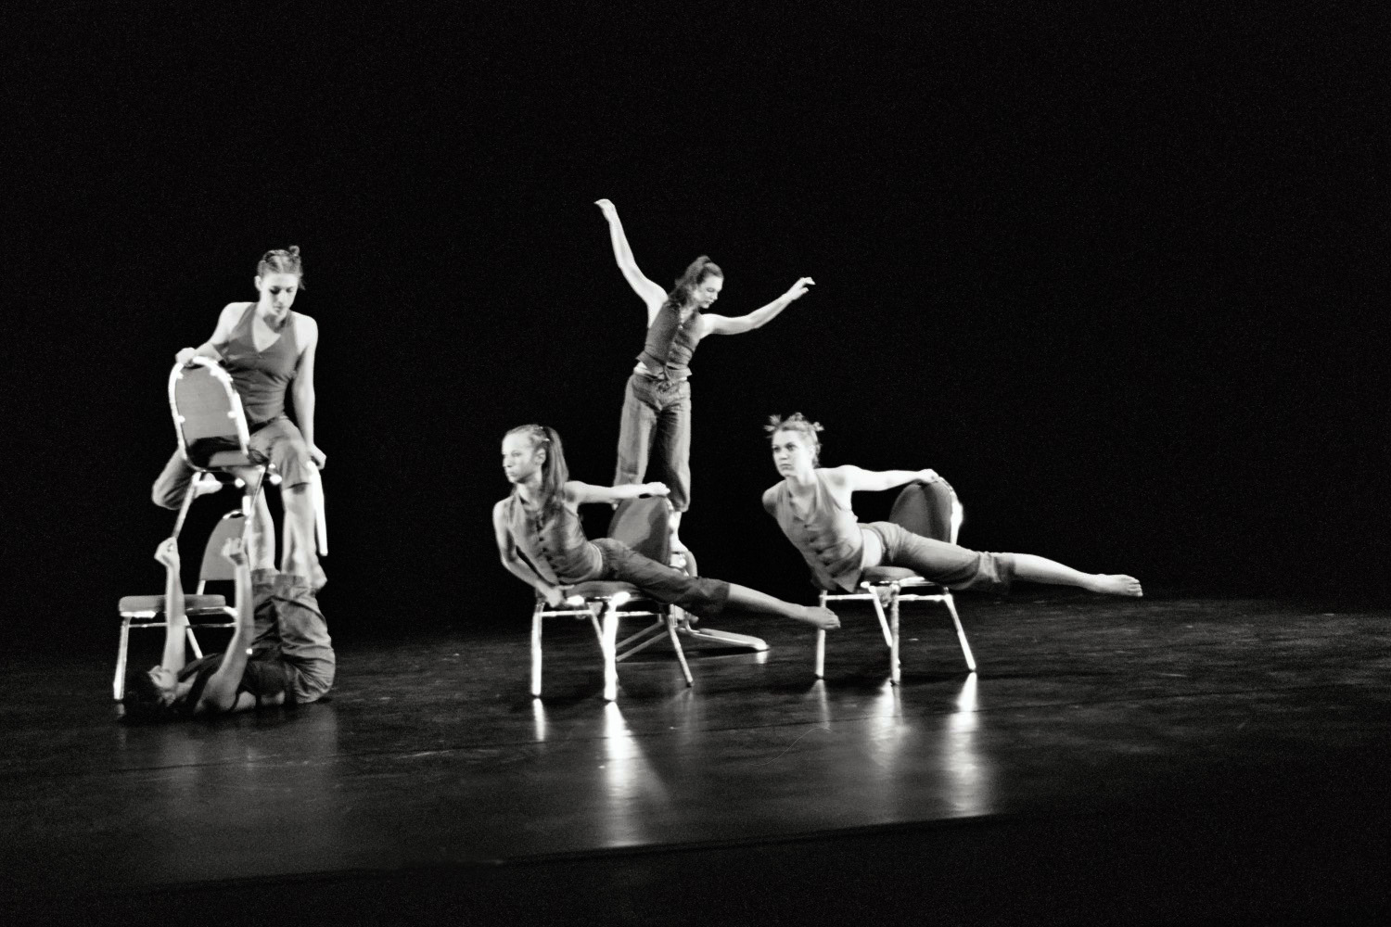
This is…?  Dancers perform the same motif at the same time but starting from different points in the phrase. |  |  |  |  |  | What does it all mean?  This form of canon can give the impression of a very ‘busy’ stage but at the same time movements are echoed throughout a group. There is still complementary harmony within this device.
Mr R recommends…
  Example…
  A |  | 1 | 2 | 3 | 4 | 5 | 6 | 7
  B |  | 6 | 7 | 1 | 2 | 3 | 4 | 5
  C |  | 3 | 4 | 5 | 6 | 7 | 1 | 2
  D |  | 7 | 8 | 1 | 2 | 3 | 4 | 5
…try placing dancers very close together when doing this for a strong visual impact.
COMPOSITIONAL DEVICES
Numeric Variations |  |  |  |  |  | “Slick transitions from one numeric variation to the next is the mark of a very good choreographer!”
This is…?  Numeric variations refer to the variety of combinations of ‘groupings’ that can be achieved through splitting up a number of dancers. Within these ‘groupings’ dancers could be doing anything: stillness, unison, cumulative canon, retrograde, amplification, a combination of things… |  |  |  |  |  | Why use it?  By constantly creating, changing and shifting ‘groupings’ a choreographer can create a very strong piece of work that slickly moves from one aesthetically pleasing moment to the next. A choreography where all 5 dancers dance as a whole all of the time is a one way ticket to Snoreville!
Example…  A group of 5 dancers can broken up into:  1 + 1 + 1 +1 + 1  1 + 3 + 1  1 + 2 + 2  3 + 2  Can you think of others? |  |  |  | 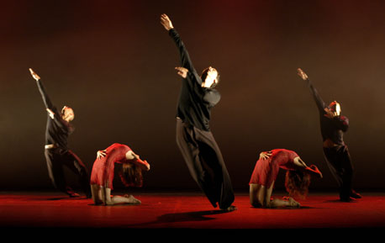
Mr R recommends… |  |  |  |  |  | “A choreography where all 5 dancers dance as a whole all of the time is a one way ticket to Snoreville!”
…using as many different numeric variations as possible. Slick transitions from one numeric variation to the next is the mark of a very good choreographer!
COMPOSITIONAL DEVICES
Juxtaposition |  |  |  |  |  | “Sloth next to lightning speed helps to make each other dazzling.”
This is…?  This is the art of placing two or more extreme contrasts very close together. These contrasts could be of speed, open and closed positions, levels, size, angular and soft lines… |  |  |  |  |  | Why use it?  This is quite possibly the most powerful tool for a choreographer; it can highlight the differences between characters or status on a narrative level. On an abstract level this can be breathtaking. If it works for Henri Oguike and Matthew Bourne…
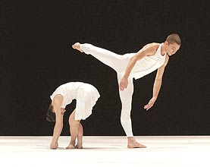
Mr R recommends… |  |  |  |  |  | “On an abstract level this can be breathtaking. If it works for Henri Oguike and Matthew Bourne…”
Quite possibly the most visually attractive type of juxtaposition is that of extreme speed. Sloth next to lightning speed helps to make each other dazzling.
 | COMPOSITIONAL DEVICES
 | Question and Answer
 | This is…?  Question and Answer is a form of relationship between dancers upon a stage. One dancer performs a series of movements whilst another is still. The second dancer will then perform another series of movement, whilst the first is still, as if answering. |  |  |  |  |  | Why use it?  This is a good compositional device to show a difference of opinion on stage, or to show some level of conversation between dancers. If dancers are of opposing ‘opinion’ then movement should reflect this and vice versa.
 |  |  |  |  | 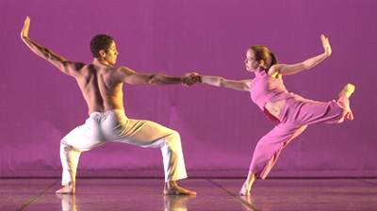
 | Mr R recommends…
 | It’s easy to use this too simply. Try observing a heated argument and use this device to reflect that; bursts of different lengths and intensity overlapping one another.

COMPOSITIONAL DEVICES
Complement
This is…?  When the essence of a shape, movement or quality of one dancer is echoed by another. |  |  |  |  | Why use it?  This device can create a harmonious relationship on stage by unifying dancers in similar shapes that are naturally pleasing to the eye but without resorting to unison or copying.
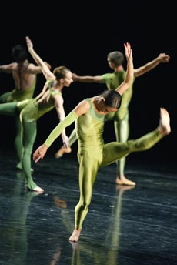 |  |  |  |  | 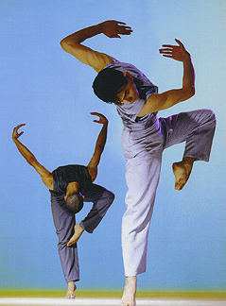
Mr R recommends… |  |  |  |  | “…create a harmonious relationship on stage by unifying dancers…”
Don’t just use this for complementing shapes. Try complementing pathways, rhythms or dynamic structures for a more advanced approach.
COMPOSITIONAL DEVICES
Fragmentation
This is…?  Dancers within a group perform completely different movements to each other as far away from each other as possible. |  |  |  |  | Why use it?  This device can create visual disharmony, causing the stage to look very busy or chaotic. This device is particularly effective when used in small amounts.
 |  |  | 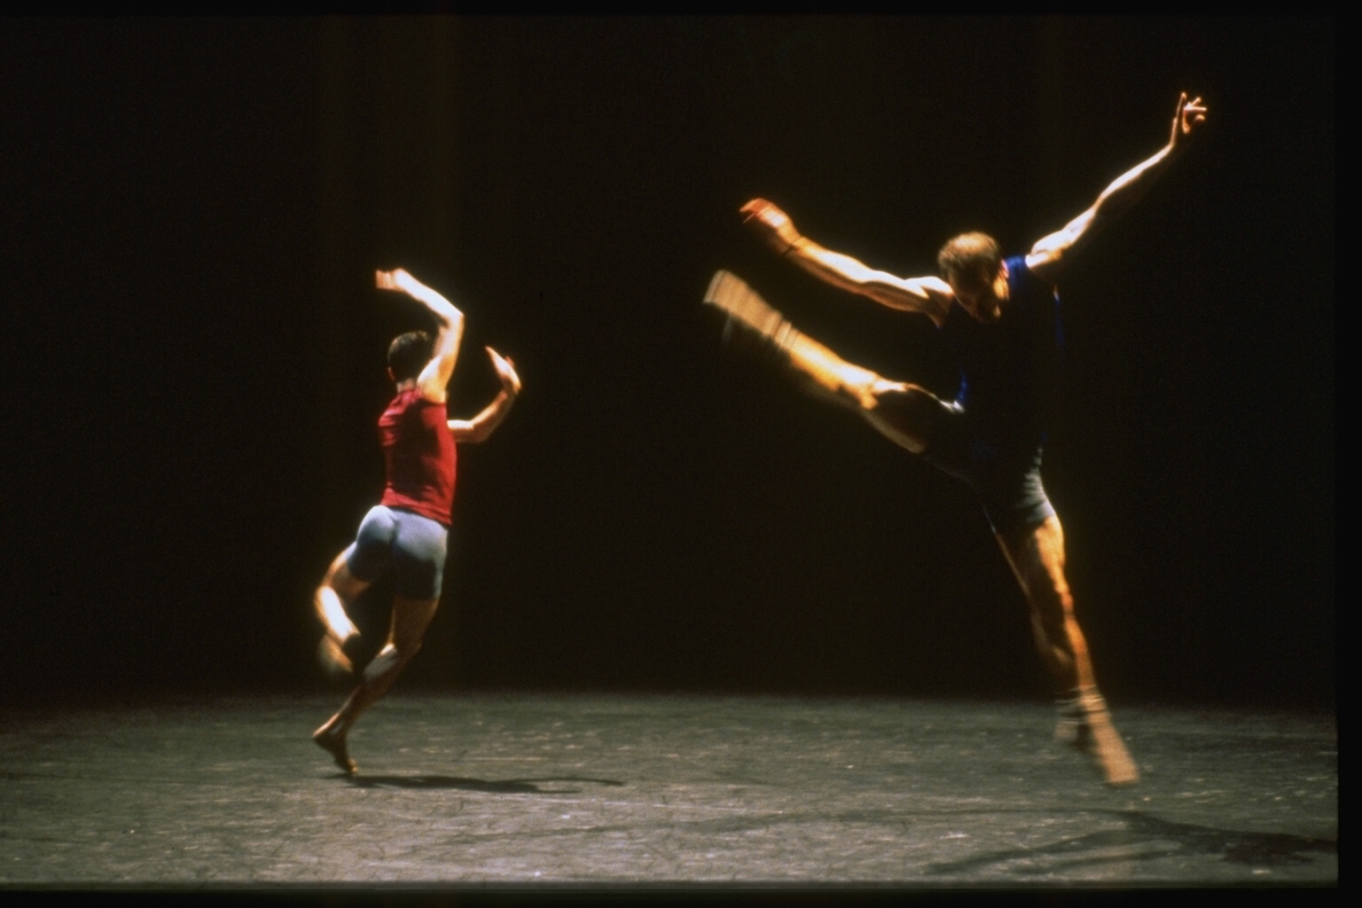
Mr R recommends… |  |  |  |  | “…causing the stage to look very busy or chaotic…”
This device can look highly effective when used sparingly (not very much!). Avoid overloading your dance with this, else it will look clumsy and unplanned.

COMPOSITIONAL DEVICES
Action and Reaction
This is…?  This occurs when the movement of one dancer initiates another dancer to respond. This device is more commonly used in contact work.  In its contact form this is also known as Movement Initiation or Antagonistic Movement. |  |  |  |  |  | Why use it?  This device is more commonly used to display a level of control one dancer has over another, frequently with one dancer standing over another and using their hand like a ‘wand’ that initiates movement. This is VERY basic. In a more complex and pleasing form this can be used to physically prompt dancers to move.
Mr R recommends… |  |  |  |  |  | “…one dancer standing over another and using their hand like a ‘wand’…it’s very basic and overused!”
…strongly against the ‘hand waving/spell casting’ use of this device; it’s very basic and overused! Use it in contact form, with more dancers!
QUICKGUIDE: Motif Devp
ACTION | Addition |  | Adding extra movements in to the motif in order to make it longer |  |  |  |  |  | EASY
ACTION | Reduction |  | Taking movements away from a motif in order to make it shorter |  |  |  |  |  | EASY
ACTION | Ornamentation |  | Adding extra actions to already existing movements in order to make them more complicated i.e. adding loops or wiggles |  |  |  |  |  | MEDIUM
ACTION | Body Part |  | Changing the body part that is used to execute movement i.e. using an arm instead of a leg |  |  |  |  |  | MEDIUM
ACTION | Splicing |  | Taking two different motifs and combining their content |  |  |  |  |  | MEDIUM
ACTION | Repetition |  | Repeating the existing movement in its original order |  |  |  |  |  | EASY
ACTION | Restate |  | Repeating a movement on the other side of the body |  |  |  |  |  | EASY
ACTION | Reiterate |  | Repeating a movement over and over |  |  |  |  |  | EASY
ACTION | Accumulation |  | Repeating and adding movements into a motif in order to lengthen it i.e. 1, 1 2, 1 2 3, 1 2 3 4 |  |  |  |  |  | MEDIUM
ACTION | Reorder |  | Jumbling the order of the movements in the motif |  |  |  |  |  | MEDIUM
ACTION | Reverse |  | Reversing the order of the movements in the motif |  |  |  |  |  | MEDIUM
QUICKGUIDE: Motif Devp
ACTION | Retrograde |  | Performing the motif backwards, as if being rewound on video |  |  |  |  |  | HARD
SPACE | Direction |  | Changing the direction a movement/position faces |  |  |  |  |  | EASY
SPACE | Amplification |  | Increasing the size of a movement |  |  |  |  |  | EASY
SPACE | Miniaturisation |  | Decreasing the size of a movement |  |  |  |  |  | EASY
SPACE | Level |  | Altering the level at which a movement is performed i.e. high, medium, low |  |  |  |  |  | MEDIUM
SPACE | Plane |  | Changing the corridor that a movement is performed in i.e. door, wheel, table |  |  |  |  |  | MEDIUM
SPACE | Pathway |  | Altering the pathway that a motif travels upon |  |  |  |  |  | MEDIUM
SPACE | Inversion |  | Flipping a movement 180 degrees so that it is upside down |  |  |  |  |  | HARD
DYNAMICS | Speed |  | Changing the amount of time spent on performing the movement |  |  |  |  |  | EASY
DYNAMICS | Dynamics |  | Changing the quality and energy of the movement |  |  |  |  |  | MEDIUM
DYNAMICS | Rhythm |  | Rhythm is the structuring of action and stillness within a motif; by altering the time pauses occupy you alter the rhythm. |  |  |  |  |  | MEDIUM
QUICKGUIDE: Comp Devs
Unison |  |  | All dancers performing the same movement at the same time. |  |  |  |  |  | EASY
Canon: Simple |  |  | All dancers performing the same movement at different times to each other: in order |  |  |  |  |  | EASY
Canon: Random |  |  | All dancers performing the same movement at different times to each other: randomised order |  |  |  |  |  | EASY
Canon: Cumulative |  |  | One dancer will start a phrase and other dancers will join in at various stages. All dancers finish with the same movement at the same time. |  |  |  |  |  | MEDIUM
Canon: Simultaneous |  |  | Dancers perform the same motif at the same time but starting from different points in the phrase. |  |  |  |  |  | MEDIUM
Numeric Variations |  |  | The variety of groupings that dancers can be placed in i.e. a group of 5 dancers can be arranged in to 1 + 4, 2 + 3, 3 + 1 + 1 etc.
Juxtaposition |  |  | Two or more contrasting elements are placed in very close range to one another. |  |  |  |  |  | MEDIUM
Question and Answer |  |  | One dancer will perform movement as if asking a question. Another dancer will perform a movement in response to that question |  |  |  |  |  | EASY
Complement |  |  | Movements of similar (not the same) design, shape or quality are used at the same time in order to create harmony |  |  |  |  |  | EASY
Action/Reaction |  |  | One dancer initiates another dancer to respond. This device is more commonly used in contact work. |  |  |  |  |  | MEDIUM
Fragmentation |  |  | Dancers perform completely different movement separated from each other. The dance is broken apart! |  |  |  |  |  | MEDIUM

